Create product in WHMCS with existing Sentora user

In Setup > Products and Services > Products and Services

Edit your hosting plan > Module Settings and select either 1st, 3rd or 4th option

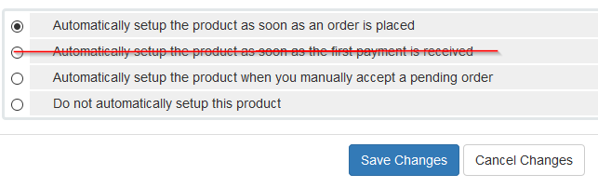

Now go to your client in WHMCS, and select Add New Order

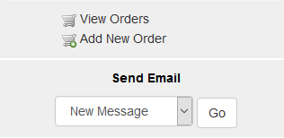

Untick Order Confirmation, Generate Invoice and Send Email, and select the hosting plan from the Product/Service dropdown, then press submit

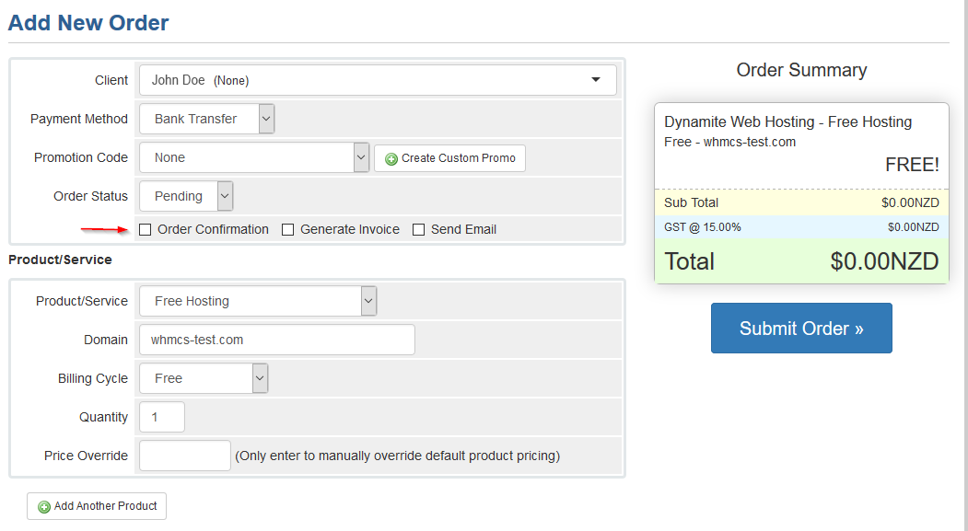

Get the username from Sentora



Now enter the current Sentora username into the username field (password doesn’t matter) and make sure the Run Module Create and Send Welcome Email are unticked, then press Accept Order

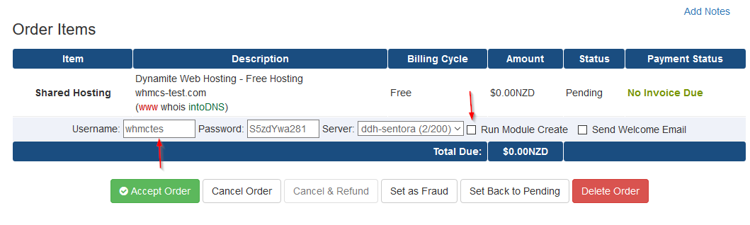

Now go back into the client > Products/Services, scroll to the bottom and press Save Changes



That’s it – now if we try and suspend this client, we get:

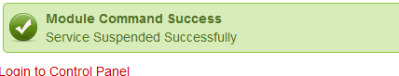

And in Sentora

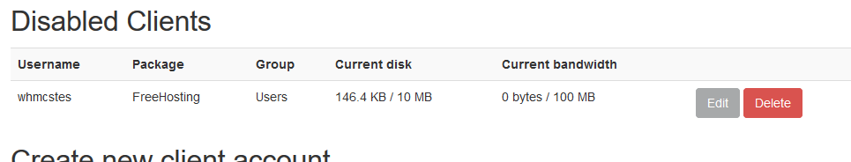

And now set the Automatic setup options for the hosting plan to whichever you had before or whichever you prefer